INFT 2064 Web Technologies Assignment 2

SA Expiation Data – Part 2

Scenario

Congrats, you have been contracted by the South Australia Police (SAPOL) to build additional functionality to their data intelligence systems. Specifically, with the roll-out of mobile phone detection cameras (MPDC) in recent weeks, SAPOL are interested in determining 2 additional priority locations that would be suitable for MPDCs. Using your existing Expiations database, you are tasked with designing a system that will allow SAPOL data intelligence officers to search, filter, and identify suitable MPDC locations. Additionally, as an early tester of this system, you will also be tasked with preparing a preliminary web-based report for the police with your suggested MPDC locations and reasoning.

Additional info

React is a UI focused language, your design is also being evaluated based on its visuals. Look, Feel, UI, and UX are prioritised in this assignment. Your design should look cohesive and visually appealing. You can accomplish this with, for example, style sheets, interesting Javascript animations or transitions, as well as fetching and displaying data quickly.

You should use the look and feel of the current SAPOL website as inspiration. Be careful about copyright: https://www.police.sa.gov.au/copyright. Much of the content created by the SA Police is CCBY 4.0. so you can use it, but must include appropriate attributions if you do so. The website code itself is not covered by this license, however, so you can’t commandeer their html code, CSS, Javascript, etc.

All work is to be done individually and must be your own work. You must not use AI tools, discuss or share your React / JavaScript / JSX code anyone else. You must only submit code you have personally written (with the exception of utilising bootstrap HTML template examples, or React template examples). If you use resources, including those such as Stack Overflow articles, you must include direct links to those resources as HTML/Javascript comments in the relevant files. In Week 13 you must be able to answer questions about your code and make changes to demonstrate your understanding.

Further, you have an assessment in Week 13 where you’ll be required to demonstrate, explain, and make small changes to your Assignment 2 project. If you can’t preform these tasks, for example because your code was not written by you, or assisted with AI, you’ll receive Zero for the whole assignment.

Finally, as per the previous assignment, regular usage of Git is required and should include a full development history of the project, and you must be able to speak to and modify the code you developed or you will not receive marks for the assignment.

Tasks

This assignment is split into 2 parts. Part A and Part B.

Part A is basic and partial functionality, and is to be uploaded at the start of Week 13 (October 28th @12pm) to the course website, and then discussed in your practical.

Part B builds on Part A and is due on November the 10th. For more detail on the due dates, check the course outline. For more detail on the contents of Part A and Part B, read on!

Part A [50%] – Website prototype & Basic functionality

Website Prototype
Before you start your other assignment Tasks, you should design and plan your website. This includes planning the Pages and Layout your React application will use, as well as preparing a Paper or Digital prototype to show to your tutor during your practical session in Week 12.

During Week 12, you will you’ll have the opportunity to demonstrate / walk-through a Prototype or Wireframe during the practical session. Your tutor will act like the client, here, and ask you a couple of questions about your design. You need to include pictures of your Prototype as part of your Part A and Part B submissions. The Week 12 practical session will be the last opportunity to get feedback on your design before Part A is due on October the 28th.

Once you have uploaded your design as part of your Week 13 Part A submission, you’re allowed to iterate on it, but shouldn’t radically deviate from your planned prototype.

Login page
Your first coding task, in order to you get used to the React framework without worrying about the Expiation data yet, is to create a straight forward Login page for your Dashboard.

For these flows, use the installed crypto-js library to hash the user’s password with SHA256 before sending it to the API endpoint. You can see an example of the Javascript side hashing in App.js, and the server side check in Assig2/Controllers/API/EndpointController.cs .

During the Login flow you should send the userName and passwordHash to the API endpoint via POST at /api/Login, which will verify the hash you submitted and send a response. This is a toy example, so there’s a couple of hard-coded Logins in the MVC application.

During the Register flow you should send the userName and passwordHash to the API endpoint via POST at /api/Register, which will verify the username isn’t already in the userName set, and that the passwordHash is the right format, then send a response.

Website Template
Now that you’ve finished creating a Login page, you should create the rest of your website’s template. You can create some skeleton React components here. The whole site should be navigable, but you don’t need to implement the fetches or do any processing, just the outline and template for the site.

Fetch suburb list from API endpoint
For this task, use some basic React code to fetch the suburb list from the /api/Get_ListCameraSuburbs endpoint and bind it to a React component, such as a dropdown list.

Submission
For Part A your website can be basic but navigable. The Login page & suburb list should be functional. Your template should “work” in the sense you can click around, but other pages don’t require content. Zip up your project and upload it to the course website once complete. Make sure to include your .git folder as well as your Prototype images in this submission.

Part B [50%] – Full functionality and Report

The MPDC Dashboard
Once a user has logged in via your Task 1 page, a React based Dashboard should be displayed allowing a user to use search terms and filters to identify and prioritise MPDC locations.

The dashboard should make use of at least 4 different types of control to help search through and filter locations for MPDCs. As with the tasks of the previous assignment, you should start with an Autocomplete Textbox, and a Dropdown List. After this, you must include (at least) 2 additional types of controls – Date Select, Radio Buttons, Checkboxes, Selection List, etc. For ideas, take a look at the Core React Components.

The exact queries and types of controls you use for searching and filtering are up to you, but should be sensible when viewed from the scenario purpose – to identify potential MPDC locations.
Once 2 locations have been identified as part of this dashboard, this page should link to the report, where you display the selected MPDC locations. In this assignment, your report can use hard-coded locations (i.e. you assume the user used the dashboard and selected your favourite 2 locations).

The Report
This task requires presentation of a React page with your 2 suggested MPDC sites.
Your report should include the following contents:
- The 2 selected MPDC sites
- Screenshots from Google maps or similar displaying where the site are located. (Bonus points for using a maps integration to show the locations, like MapQuest or OpenStreetMap.)
- A description of what filters and search options you used in the dashboard to identify these sites, including screenshots.
- At least 2 D3 graphs displaying some interesting information about the sites, and also related to the filters and search options used in the previous task.

Your report should also be appropriately styled with CSS and look visually appealing. This report doesn’t need to be very long (< 750 words, please) but should justify why the locations you have identified are the best candidates for the MPDCs. You must analyse the API data used in the previous task, but may also incorporate any other data sources or considerations you wish – for example, road design considerations or obstructions, physical space available to install the cameras, crash data near the location, etc.

Submission
For Part B your website should now be complete. The Login page, Dashboard, and Report pages should all be functional. Pages from Part A should now be styled. Your website should look nice, and be easy to navigate (good UI / UX). Zip up your project and upload it to the course website once complete. Make sure to include your .git folder as well as your Prototype images in this submission.

Using the Swagger Web API Interface

- Run the Assignment 2 MVC Web Application and use the link on the home page to view the available controller actions via Swagger.
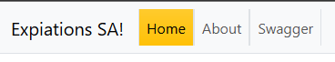
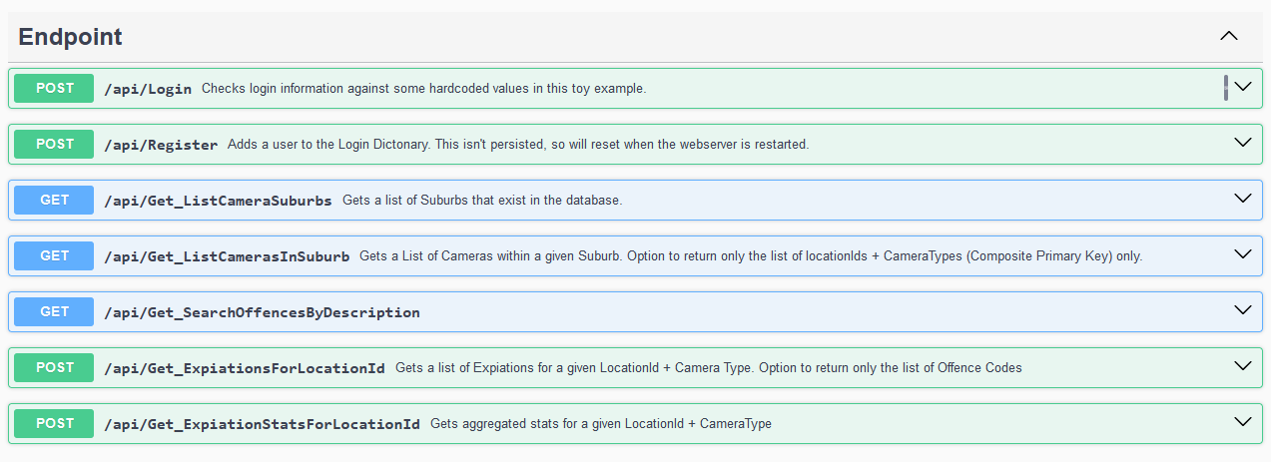
- Expand an action to view the list of input parameters and output JSON schema. For this endpoint, there are no input parameters, and the output is a list of suburbs.
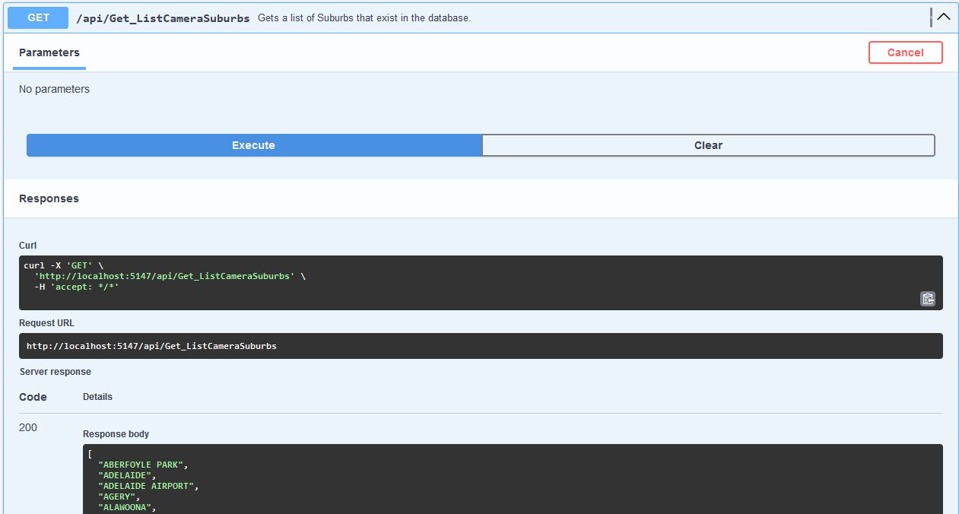
- In a more complex example, we’ll use the Post method with a number of input parameters.
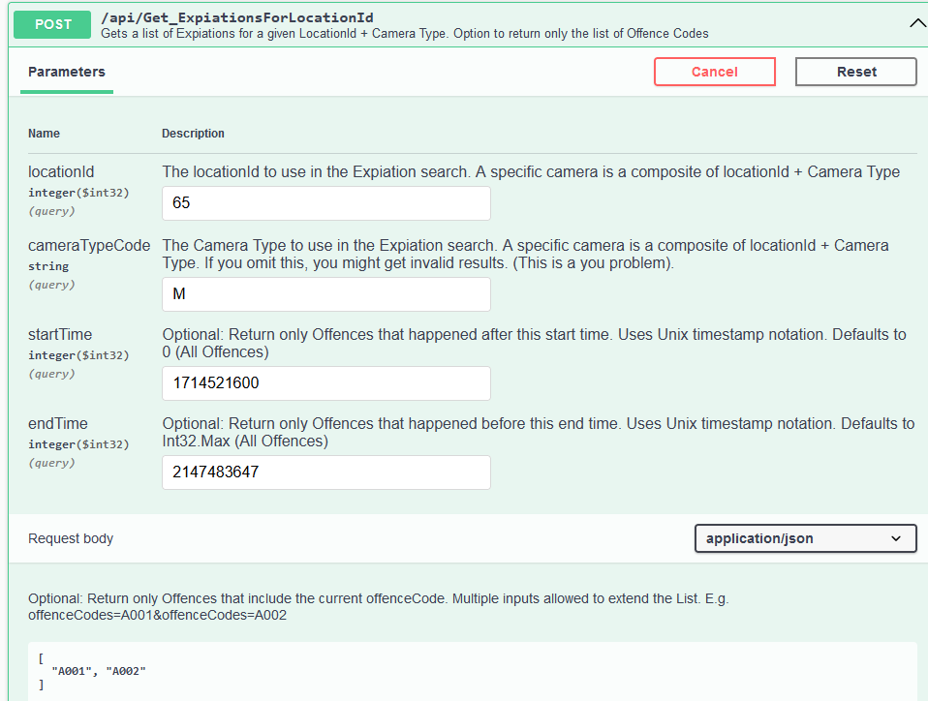
Note: startTime and endTime are unix timestamps. You might have to convert your date into a timestamp integer. For the offenceCodes list, you need to send in a list of offenceCodes as per the example above, in the format: [“A001”, “A002”].
Output from the example shows a slightly more complex JSON response, outputting data from the Expiations table.
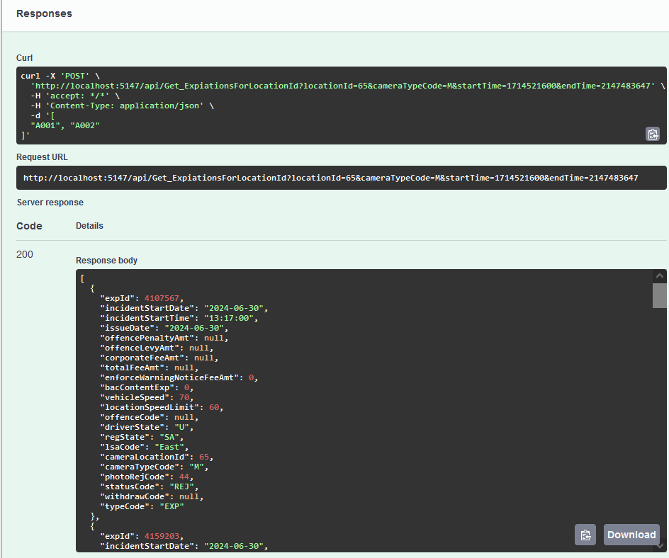

Installing the ReactJS Application

Using VS-Code OR Visual Studio 2022 You will need to install the ReactJS application which has already been created for you in the above MVC application.
- Using the Terminal Window of Visual Studio with the MVC application loaded, navigate to the a2reactapp folder:
> cd Assig2/a2reactapp
- Install the react app (this will re-create the missing node_models folder)
> npm install
- Once installed, test the reactJS application works
> npm start

FAQs

I don’t like your Endpoints. Can I request new ones?
  - Yeah, if you want something in particular, ask in the Discord and I might be able to accommodate you.

I am extremely powerful and regular D3 graphs are beneath me, make it harder.
  - Ok, not really a question, but I saw a student in Assignment 1 use D3 in conjunction with GeoJSON to display suburb data. The data.sa.gov.au website has GeoJSON encoded information about suburbs and also crash data that you could potentially incorporate into your assignment somehow, check it out.

I want to do something else interesting🤔
  - Run it by Mark or Doug, as long as it doesn’t make the assignment easier, or too difficult to assess, it should be OK.

Marking Guidelines

Pass – Basic but functional
You implement most of the tasks above, with some gaps (e.g. no graphs.) Website lacks any real styling or is slow to load and retrieve data. API calls work, but edge cases aren’t accounted for and cause errors.

Credit – Fully operational battle station
The requirements for Pass are met. All or almost all of the functionality described in the tasks is implemented. Slow responses, errors, and other unexpected server behaviour is minimised.

Distinction – Witness Me
The requirements for Credit are met. Website looks visually appealing. Care has been taken to ensure the website UI and UX is pleasant. Report presents good insights. Git commit history is well paced and descriptive.

HD – This is to go ever further beyond
The requirements for Distinction are met. Website UI and UX is top-tier. Insights for MPDC locations are genuinely interesting and convincing. If I were the client in this scenario I’d be saying “wowee”.

Git Commit
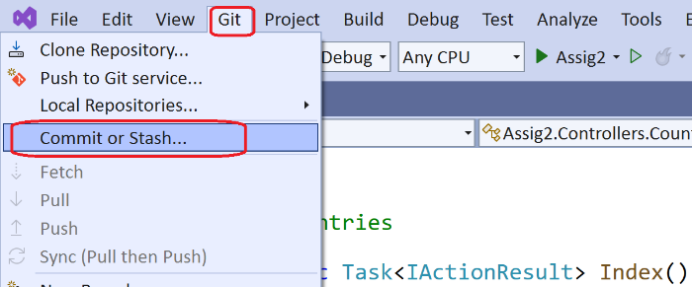
Committing your progress is as easy as 1,2,3!
If your Git window is not active, simply go to the Git menu and select the “Commit or Stash” option.
Then:
- Name your commit based on what you did
- Commit the change!
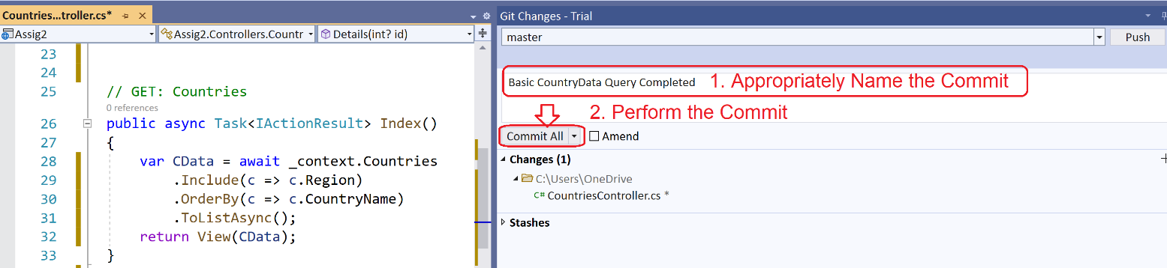

Uploading your Project
Once you have completed your project:
- Close Visual Studio and navigate to the folder containing your whole web application
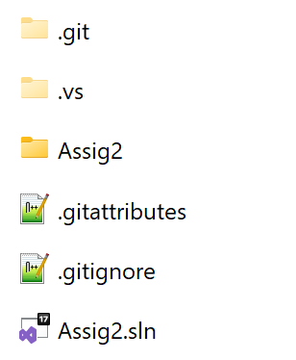
- Zip up the entire web application. This folder must include your .sln file, your project directory, git directory and git support files as pictured. This is important:
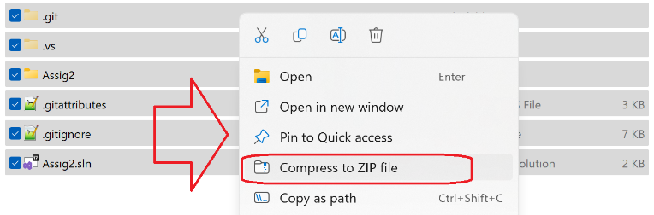

If you’re on Mac, hidden folders like “.git” won’t be included in your archive by default!
- Remove the node_modules folder from the zip file (located under Assig2/a2reactapp). If you’re feeling confident about your project, you can remove the node_modules before zipping. You will then have to npm install to get them back.
- Upload to the course website

Late Submissions
As per Assignment 1: no ifs, ands, or but-the-deadlines. Late submissions will not be accepted for this assignment.

Downloading the Database
You will use your existing database connection and data from the previous assignment. But, in case you’ve forgotten, the instructions from Assignment 1 are reproduced here for completeness.
- Create a new Database in MS-SQL called ExpiationsDB (or similar).
- Locate the “Expiation DB Scripts” under the Assignment 1 tab.
- Run the 1_LookupTables.sql queries to generate the lookup tables
> Check the number of records against the numbers published on the course page
- Run the 2_ExpiationTable.sql query to make the Expiations table
- Run each of the monthly data queries under the “3_Expiation Data 2024” to load the expiations table with data. NOTE: some of these files are large and will take time to execute. If your computer times out, you will need to highlight 3000-5000 rows of insert statements as necessary and execute them individually to get it working.
- Run the Index Queries (note that you can choose indexes relevant to the tables you are using)
- As a minimum you need to load 2024 data, but you are welcome to try other data from 2023 etc to test Monthly breakdowns are functioning correctly etc and for your own interest :)

https://my.unisa.edu.au/public/CourseOutline/ViewOutline.aspx?id=49178
https://www.npmjs.com/package/crypto-js
https://reactnative.dev/docs/components-and-apis
https://developer.mapquest.com/documentation/api/static-map/
https://github.com/jperelli/osm-static-maps
https://www.unixtimestamp.com/
https://www.d3indepth.com/geographic/
https://data.sa.gov.au/data/dataset/?res_format=GeoJSON

